**How To Run Chapter 6 Example Code**

Notice: There are 3 solutions in the Code folder, all of which are essentially identical. The only differences are in some variances for Basic Authentication (BasicAuth_CsIppRequests) or checking file type support (CsIppRequestsAdditional).

To run an example checking Basic Authentication support, use the BasicAuth_CsIppRequests solution. However, you will have to set your printer to use IPP Basic Authentication, and example of how to do this for HP printers is shown in the chapter.

**IppPrintRequest**

1. Navigate to: \code\CsIppRequests\IppPrintRequest\bin\Release
2. Open a Console Window.
3. Usage: IppPrintRequest <full path to print job attributes file>
4. An example job attributes file can be found in the \code\CsIppRequests\IppPrintRequest folder. This is printer-specific (HP M528 printer) and will need to be altered for your IPP printer.
5. Example: IppPrintRequest.exe" C:\temp\JobAttributes.txt
6. The utility will prompt you for any information it needs, for example, it will ask

Would you like to validate, create, cancel, senddoc, or printjob?

Note: If you run this in the debugger, set the Startup Project to IppPrintRequest.

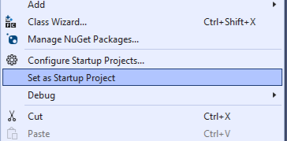

1. The DLL is created in the CsIppRequestLib Project which is in the same Solution.